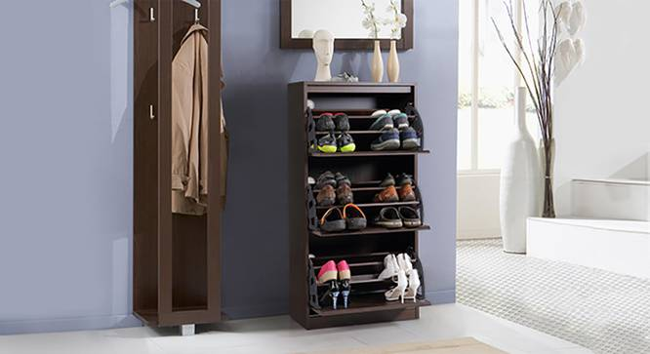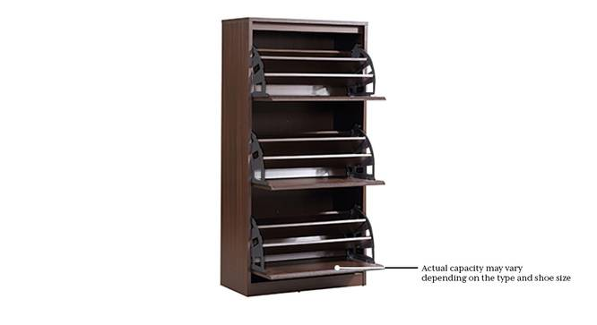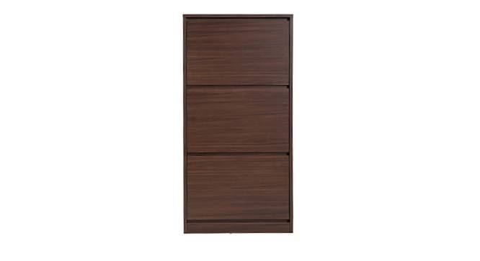

* Completely on Pointe. This convenient, functional shoe rack is neat, with a compact footprint. The cabinet door swivels open, providing easy access to any pair you want.
* The unobtrusive design allows it to blend into the background with the dark walnut, walnut finish, or become a colourful accent for your room with the glossy red option.

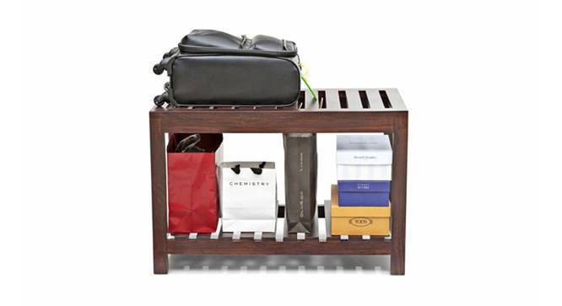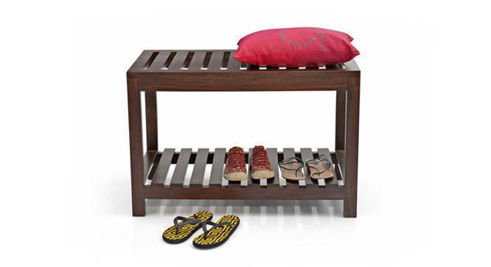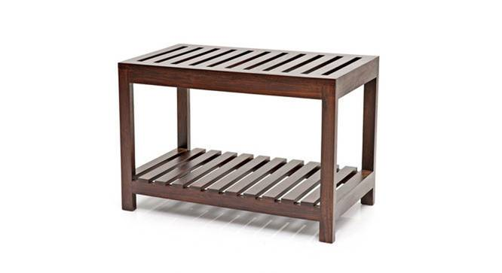

* Slatted top rack cum bench, looks good and works hard
* The Marco can have multiple uses, in the bed-room, guest-room or entry-way
* Perfect height for keeping luggage or to sit on while putting your shoes on